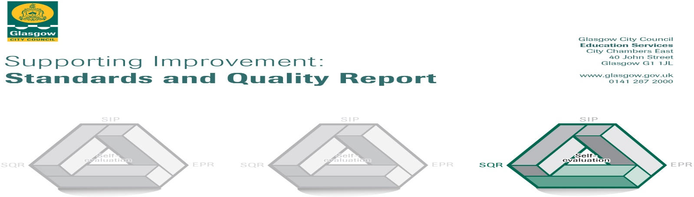

Garnetbank Primary School 2018-2019 The summary report is provided for parents/carers and partners to outline our achievements this session and our priorities for next session. Throughout this session we have taken forward our priorities as detailed in our school improvement plan. Through our processes of self-evaluation, we have identified how we can improve outcomes for our children and young people. (V5)

Our achievements and improvements this year.
- We would like to highlight the following improvements/achievements
- Scotland Reads: Mrs Simpson (funded by pupil equity grant) trained over 30 volunteers to work with children weekly on the Scotland Reads programme. We have recorded great improvements in reading ability for the children involved and plan to continue to expand this successful programme.
- National Play Award: We have developed opportunities for every child to play more at break and lunch in Garnetbank, supporting children to develop and apply skills in creativity, problem solving, team work and much more. This has been supported by an additional support for learning worker and child development officer (funded by pupil equity grant) and has resulted in recognition by Play Scotland and the Nancy Ovens trust.
- Numeracy and Maths: We continue to embed the Glasgow Counts programme and all of our staff have engaged with additional training, enhancing children’s learning.
- Literacy: This was our second focus year in Glasgow’s improvement challenge, which resulted in improved experiences for all of our children. We are reducing poverty related barriers and closing the gap for some children through enhanced learning and teaching approaches, in addition to targeted intervention group work. We have successfully supported many children involved to move back ‘on track’ in their learning or make significant progress through our literacy ‘CLOL’ and depute head teacher.
Children’s Rights: Team Garnetbank continue to embed children’s rights at the heart of all we do. Positive and respectful relationships are evident throughout the school community. We were delighted to be assessed and awarded Rights Respecting School Level 1 and will continue on our journey towards level 2.
- Outdoor Learning and Learning for Sustainability: We worked with partners and across the community to host ‘Green day’ which resulted in the launch of increased learning for sustainability, funds raised for a whole school trip to BlairDrummond and bought new resources to enhance our grounds. Many partners and our community supported us to close Renfrew Street to cars for the day and give children an opportunity which some described as’ the best day of their life’! This work was highlighted and commended in the houses of parliament.
- Food Education has been a huge success: Every child enjoyed and learned through opportunities to cook and several families engaged in our ‘Kids Cook’ club. This pupil equity funded work supported children to develop technology, listening and talking and collaboration skills. The club launched our schools own healthy eating youtube channel. This work has been featured in an education Scotland case study to highlight good practice and BBC good food.

Here is what we plan to improve next year.
This session we have lots of improvement ideas and aims under three main headings - due to the extra funding received through the pupil equity fund and the opportunities for Glasgow’s improvement challenge. It will be a very busy year, with lots of exciting projects planned. Some of these aims build on improvements made last year and some are starting this year, but will continue beyond this session. The strength of Garnetbank’s relationships across parents/ children and staff will enable us to achieve the following priorities:

Raising Attainment and Achievement
- We have used some of the pupil equity funding to appoint a depute head teacher, who will lead the team in enhancing literacy and increasing parental involvement in literacy.
- We have used some pupil equity funding to appoint an acting principal teacher for early intervention and prevention (infants and literacy).
- Our child development officer will enhance learning opportunities for our younger children/ children working at early level and support the team to develop learning through play.
- We will embed our work in reading and writing and develop ‘listening and talking’ across the school.
- All staff will be engaging in professional learning on enhancing learning and teaching in literacy. Our staff will be working collaboratively to improve, evaluate and deliver a new literacy programme across the school.
- We will embed our development work in maths and numeracy, in addition to enhancing our resources to support learning and teaching.

Ensuring Wellbeing, Equality and Inclusion:
- We have used some of the pupil equity funding to create a principal teacher in health and wellbeing. This enables us to re-evaluate our whole school health programme, ensuring that it is effective and well resourced.
- Through the pupil equity fund, the principal teacher and other staff will support children to work in small health and wellbeing booster groups, increasing personal, social and communication skills and attributes.
- The school will continue to develop tracking procedures so that we ‘get it right for every child’. This means we will work together to understand a child’s needs and plan individual steps to support them in their learning journey.
- We will continue to develop outdoor learning and the outdoor learning environment to help children make connections to the outside world, apply their knowledge in new ways and increase engagement in learning.
- We will achieve the gold level of rights respecting schools.

Curriculum
- We will launch our revised vision, values and aims.
- As we have new staff, we are revisiting policies and ensuring we have progression of learning through the school.
- We will enhance learning for sustainability and work towards our next green flag.

How can you find out more information about our school?
Please contact us directly if you require further information or if you wish to comment on the report.
The contact e-mail address is:
- Headteacher@garnetbank-pri.glasgow.sch.uk
- Our telephone number is: 0141-332-5158
- Our school address is: 231 Renfrew Street, G3 6TX
- School Website: www.garnetbank-pri.glasgow.sch.uk
- Twitter: @GarnetbankPS and @PlayLearnGrowG1
- Further information is available in: newsletters and the school handbook

