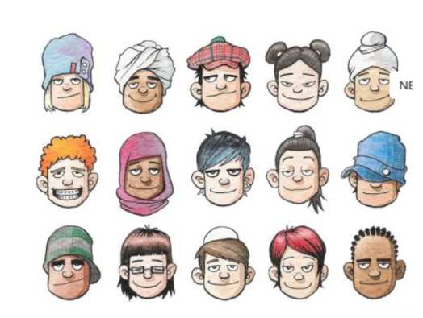
Articles 1 & 2

All children throughout
the world have rights.

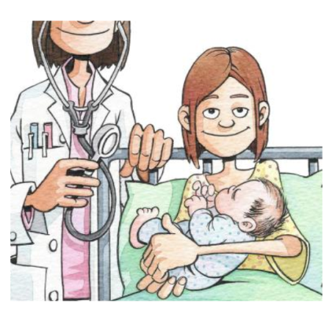
Article 6

Children have a right to
life and to develop to their
full potential.

Articles 7 & 8
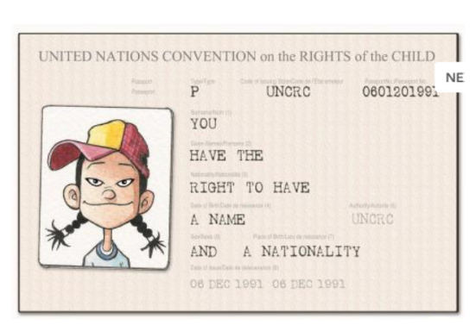

Children should have a
name and nationality.

Article 9
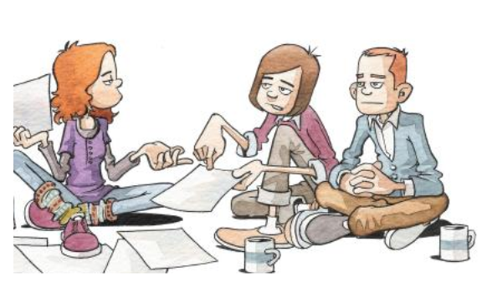

Children should live
with their parents or
someone who cares
for them.

Article 12
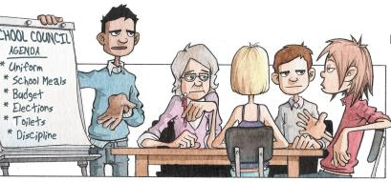

Children should be
listened to and be able
to say what they think
about things.

Article 13
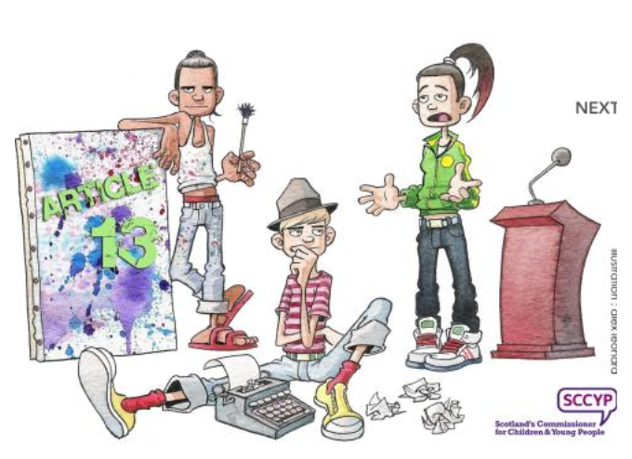

Children should be able to say
what they think and find out about
things – as long as it is within
the law.

Article 14
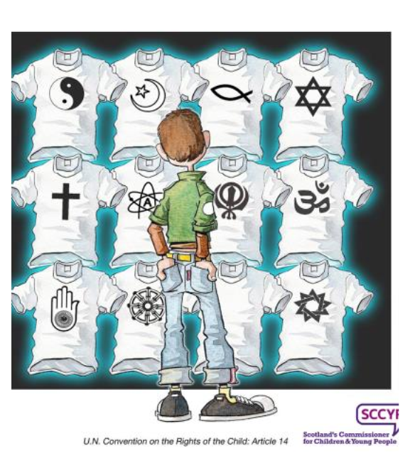

Children should be able to
worship as they wish – as
long as they respect other
people’s rights.

Article 15
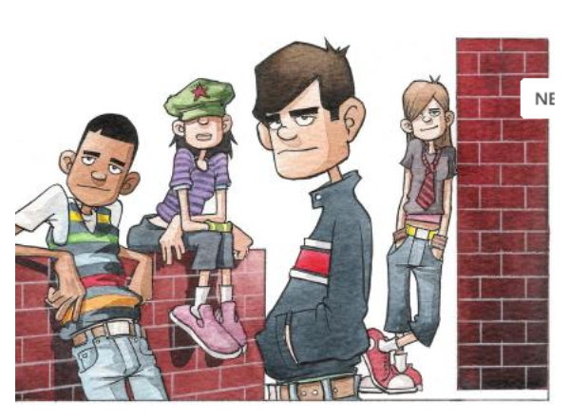

Children should be
able to meet together
and have friends.

Article 19
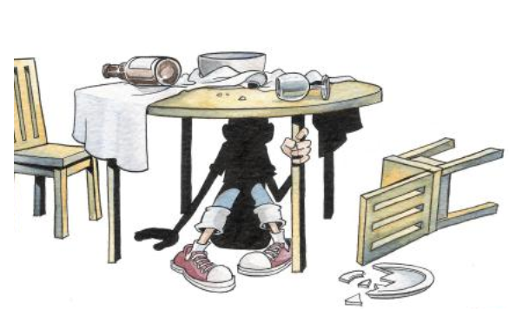

Children should be safe
from harm. No child should
be hurt by a grown-up or child.

Article 23
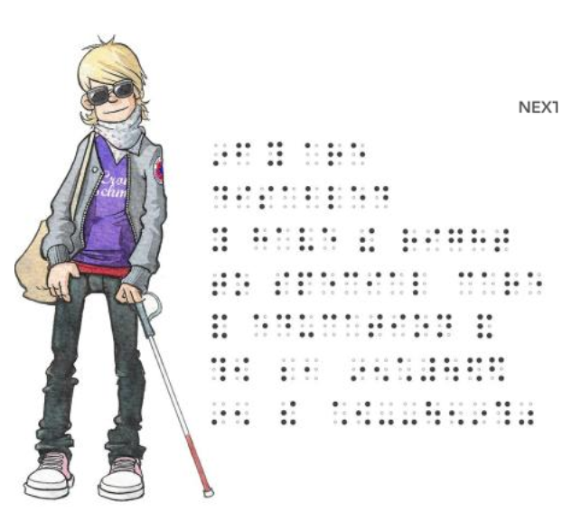

Children in need of
special care should get
it.

Article 24
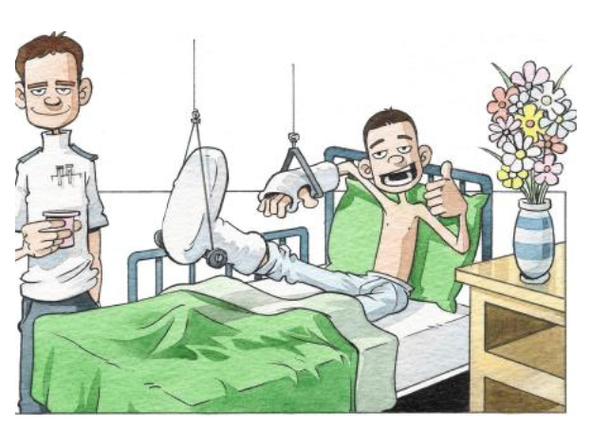

Children should have clean water,
food that is good for them, a
clean place to live and good
health care.

Article 28
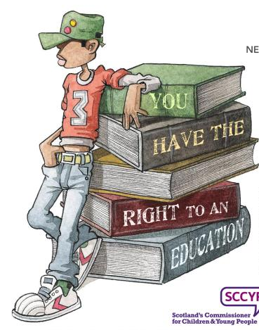

Children have the right to an
education.

Article 29

Education must develop every child’s
personality, talents and abilities.

It must encourage the child’s respect for
human rights, respect for their parents,
their own and other cultures and the
environment.

Article 30

Every child has the right to learn
and use the language, customs and
religion of their family.

.

Article 31
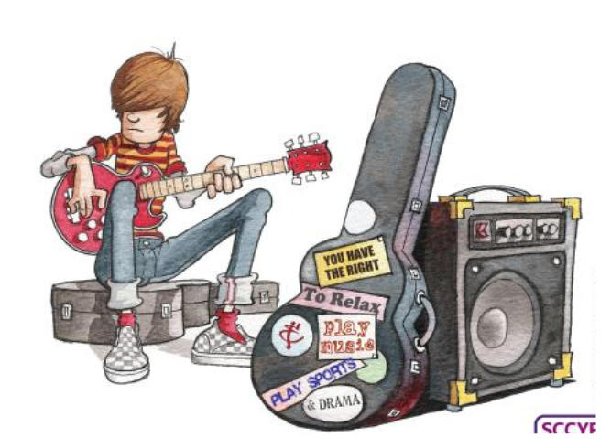

Children have the right to play,
relax and take part in a wide range
of activities.
.

Article 32

Children should not be
allowed to do dangerous
work.

Articles 33- 36

Children should be protected
from activities which stop
them from growing up
in a healthy happy way.

Article 42
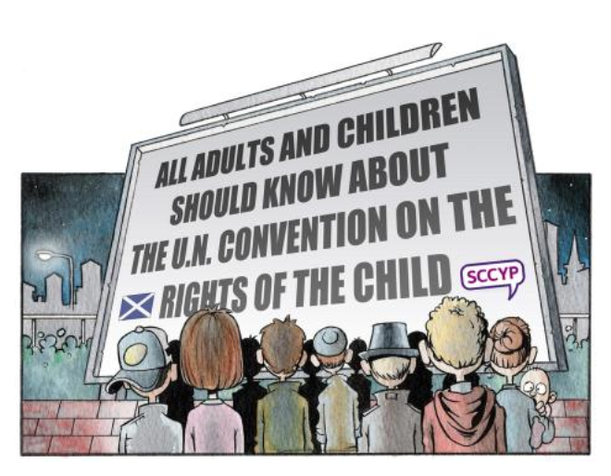

Everyone, children and
adults, should know
about Children’s Rights

