EDUCATION SERVICES

Standards and Quality Report

Garnetbank Primary School
2022-2023
This summary report is provided for parents, carers and partners to outline our achievements in 2022-2023 and our priorities for 2023-2024.
INTRODUCTION
Garnetbank’s ethos is based on its promotion of positive attitudes to social and cultural diversity. The United Nations Convention on the Rights of the Child (UNCRC) is at the heart of our school’s planning, policies, practice and ethos. As a Gold (2022) rights-respecting school, we not only teach about children’s rights in the classroom but model rights respecting language and attitudes in all of our relationships.
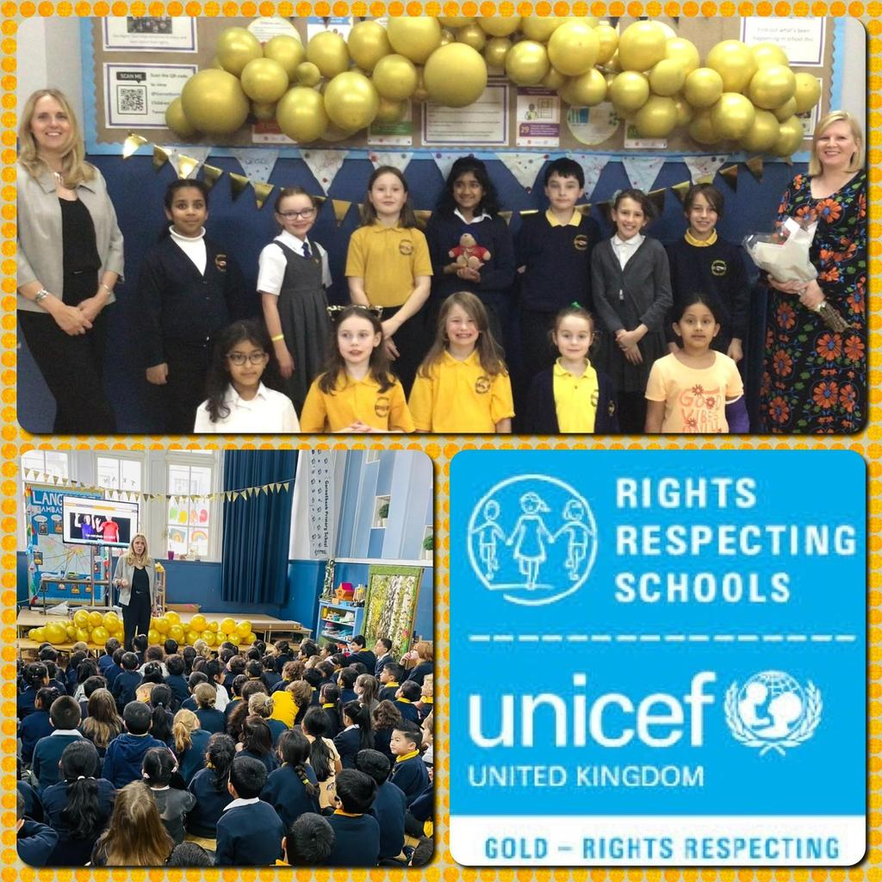

Our strong vision, values and aims are influenced by the drive to promote the rights of the child and the values of Kindness, Achievement, Integrity, Perseverance and Respect. All staff show high levels of commitment to shared values and professional standards. All staff work hard to build and sustain positive relationships, modelling the values as a team, with children and families. As a result, Garnetbank children reciprocate respect, demonstrate positive attitudes in formal learning and during social opportunities/play.

‘Team Garnetbank’ (our children, parents, carers, partners and alumni) is a collaborative, networked and empowered community - with leadership at all levels. Our curriculum rationale poster captures our shared identity, vision and values - and has been shaped by ‘Team Garnetbank’. It provides a strategic overview and focus for our curriculum decision making:

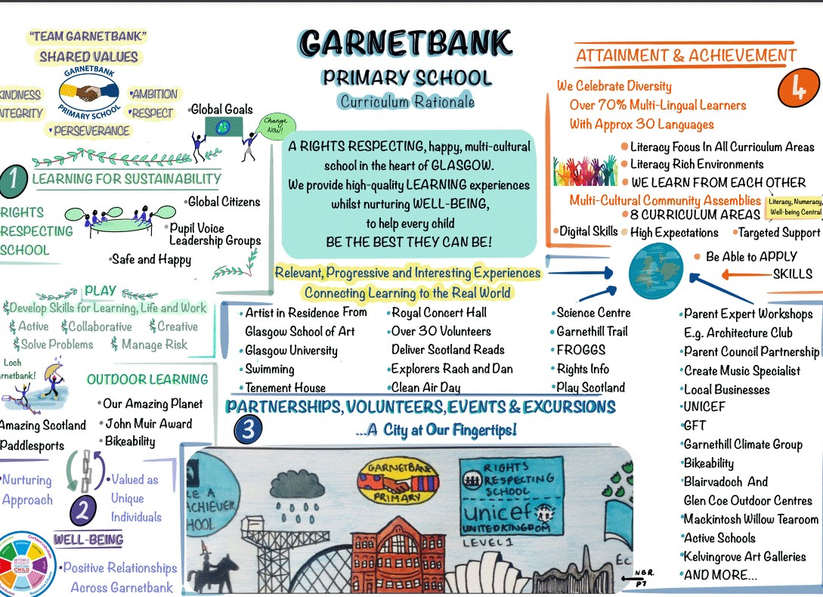

OUR ACHIEVEMENTS AND IMPROVEMENTS DURING SESSION 2022-2023
2022-2023 was the first session not affected by covid risk mitigations, following the severe disruption during the previous three sessions. Therefore, literacy, numeracy and health & well-being remained high priorities, in order to continue to close the gap and remove barriers to learning and achieving. The session saw many successes and improvements, to the benefit of our children. Here are a few examples:

- Following over ten years of rights work, Garnetbank was inspected by UNICEF and accredited with GOLD Rights Respecting Schools Award in November 2022.
- Our curriculum rationale is understood and embedded in our practice. Garnetbank has been able to share good practice and supported other schools in Glasgow and beyond, to create their own curriculum rationale.
- In May 2023, Garnetbank was selected to represent Glasgow for its primary curriculum in a national thematic review by His Majesty’s Inspectorate (HMI). This was a very positive visit, resulting in the school being asked to provide a case study to share good practice nationally. During the inspection, all staff, parents, children and partners were able to talk about high quality learning and teaching, our positive ethos, meeting the needs of our individual learners and how the rationale brings the curriculum to life.
- In May 2023, a survey for parents and carers, highlighted the positive views parents and children have of their school. Almost all parents felt children were making very good or good progress in literacy, numeracy & health and wellbeing.
- Parents and partners regularly comment on the positive ethos, vision and values through online surveys, parent assemblies, parent coffee afternoon sessions, seesaw and through the medium of twitter.
- Following several years work on developing ‘play pedagogy’, Team Garnetbank co-created and achieved GOLD Play Pedagogy Award with the national organisations ‘A Place in Childhood’ and ‘Play Scotland’ in January 2023. This represents the excellent provision for Garnetbank’s children in learning through play.
- Garnetbank continues to reduce barriers to learning through innovative and targeted support. The pupil equity fund enabled us to increase bespoke sessions to meet the needs of all learners. This included the use of an i-robot, toast club, the introduction of ‘Seasons for Growth’, wellbeing groups and enhanced use of ipad accessibility features. We were able to report on most children receiving these interventions making progress in the desired area.
- Four staff completed the extensive ‘Apple Coach’ training, who now continue to mentor colleagues in digital learning strategies.
- All staff and children enhanced their digital skills.
- The roll out of 1:1 ipads for all P5 to P7 was implemented and access to ipads at all stages enabled.
- The digital group created a video for children, staff and parents on how to use accessibility features on iPad to enhance and support learning, with positive results.
- A £1000 grant from the ‘Glasgow Virtual School’ enabled us to create a cosy nurture space called ‘The Coorie’. During the year, a teacher funded through the pupil equity grant, worked with small groups to continue to support health and wellbeing and smooth transitions.
- We made excellent use of partnership opportunities to enhance learning and engagement: RSNO, UofGlasgow, WOSDEC, BBC, FROGGS, GSoA, UNICEF, Garnethill Climate Group, the science festival, Dandelion project and litter picks with Keep Scotland beautiful
- Garnetbank and Glasgow School of Art designed a unique ‘artist in residence’ opportunity, which began in January 2020 ran for the third session. A local artist was successful in a part-time funded position as an ‘artist in residence’. This session is focusing on creativity and identity/ celebrating diversity through movement and art. All children involved had an opportunity to be involved gaining opportunities: for personalisation and choice; to develop skills in in creativity and problem solving; collaboration and listening & talking. Twice weekly lunch discos have offered unique and innovative opportunities for children.
- Garnetbank recognises the importance of ‘Developing The Young Workforce’ and introduced meta-skills language to our learners. These highlighted skills are embedded in learning, teaching experiences and outcomes. Staff are using skills language to help our learners develop their own understanding of where they are and what they need to do next in their skill development journey.
- Our thriving parent council supported the school in numerous ways, including running a Harvest festival, a Multi-cultural festival, in addition to advising and raising money.
- The Garnetbank green group- a sub-group of the parent council, have made a considerable impact on greening up the outdoor environment, through fund raising and lots of hard work.

We are very grateful to everyone, who together have helped us achieve more for our children than we ever could apart.

HERE IS WHAT WE PLAN TO FOCUS ON IN 2023-2024.
High quality learning & teaching and the strength of Garnetbank’s relationships between parents/ children /staff/ partners, will enable us to achieve the following priorities:
GRAND CHALLENGE 1 - WELLBEING & LEARNING

Garnetbank will continue to increase wellbeing through universal and targeted support - and remove potential barriers to learning.
- The school will continue to develop tracking procedures so that we ‘get it right for every child’. This means we will work together to understand a child’s needs and plan individual steps to support them in their learning journey. (We will begin to use a new authority online tool to do this.)
- We will coordinate a range of additional support to meet children’s individual needs, including deploying support staff to deliver: ‘Phonological awareness training’; ‘Getting Started’; ‘Developmental P.E.’ and tailored support for individuals. We will work with other agencies to support children’s needs.
- All staff will enhance their knowledge of supporting individual needs and we will further enhance personal support for each child.
- The parent council raised funds will continue to enhance natural/ green spaces and wellbeing resources.
- There will be training for all staff on autism, dyslexia and first aid.
- The ‘Coorie Club’ will be made available to support transitions and emotional wellbeing.
- ‘Coorie’ spaces will be developed in all classroom bases to enhance inclusive classrooms and supportive spaces for emotional regulation.
GRAND CHALLENGE 2 - ACHIEVEMENT AND PROGRESS

We will ensure the curriculum develops skills for learning, life and work for all learners . Learning pathways will remain engaging, relevant and provide a broad general education. Attainment in literacy and numeracy will continue to be very good, achieved through high quality learning and teaching.

- We will work collaboratively to effectively assess gaps in learning and determine where children are in their learning to meet their individual needs. We will ‘track every’ child at least three times to support and monitor progress.
- Our ‘Challenge Leader of Learning’ will enhance our numeracy and mathematics learning and teaching. She will provide targeted support for children, enhance our resources and train staff. This will impact positively on all learners.
- We have used some pupil equity funding to continue to have an acting infant principal teacher (Ms Hearn). There will be a focus on ensuring the best start, enhancing literacy, numeracy and developing play, including a virtual teaching programme on phonics.
- Our English as Additional Language teacher has become an acting principal teacher (through pupil equity funding). In addition to supporting, children, staff and families with EAL strategies, she will continue to enhance and coordinate our family engagement and learning.
- Our child development officer, funded by PEF, will continue to enhance learning opportunities for our children working at early level. She will support the children and team to develop learning through play.
- All staff will be engaging in professional learning on enhancing learning and teaching in numeracy, additional support needs and digital technology. This will be supported by our four newly qualified apple coaches.
- We will embed our development work in literacy for all, in addition to enhancing our resources to support learning and teaching.
- Everyone will continue to explore the school values (kindness, integrity, respect, perseverance and ambition)
- Every child will continue to experience ‘emotion works’, developing shared emotional literacy
- We will embed ‘SEE-SAW’ online platform to improve remote learning and work in partnership with parents/carers. This will also enable children to take part in celebrating their achievements and considering next steps in learning.
- There will be a focus by teachers on ‘metacognition’ – learning to learn, which we know has a positive impact on all learning.
- Skills master classes will be introduced, to increase personalisation and choice in learning.

GRAND CHALLENGE 3 - CONNECTED LEARNING

Garnetbank will utilize digital innovation and digital literacy to reduce barriers to learning; to raise attainment and achievement; and enhance employability and creativity skills

- A Depute will continue to lead the team in enhancing digital learning in Garnetbank
- Children and staff will run a digital leader’s group
- Continue to roll out 1:1 iPad for P5 to P7 and access to iPads for all learners.
- We will begin the Digital Schools Award journey
- Support staff will engage in training to enhance their role in meeting learners needs.
- All staff will use a planning framework to ensure relevant, progressive learning experience in technologies.
- We will deliver family learning on digital learning

HOW CAN YOU FIND OUT MORE INFORMATION ABOUT OUR SCHOOL?
- Please contact us directly if you require further information or if you wish to comment on the report: Headteacher@garnetbank-pri.glasgow.sch.uk
(Due to email volume, please phone the school office if you require an urgent response)
- Further information is available in digital newsletters and the school handbook.
- Our telephone number is: 0141-332-5158
- Our school address is: 231 Renfrew Street, G3 6TX
- School Website: www.garnetbank-pri.glasgow.sch.uk
- Twitter: @GarnetbankPS and @PlayLearnGrowG1

