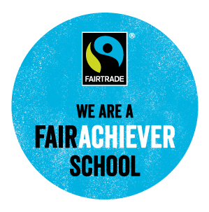

Policy
This is a really great policy – it is clear to see that you have considered each of the requirements of the FairAchiever award and worked hard to incorporate this into your policy. This really shows how committed you are to raising awareness for Fairtrade at Garnetbank. It’s great to see that it is supported by the head teacher and staff as well as pupils – this is a great way of involving the students in the Fairtrade efforts of the school and really gets them engaged in the activities.

Action Plan
Wow! You have done really well on your action plan. It is really detailed and well thought out. Plus you have managed to achieve all your plans! Don’t forget: you can include more future plans not yet completed. Great job!

Embed learning
There is a good coverage of Fairtrade across the year groups, including asking learners to explain unfairness. It is important to ensure they can also explain the benefits of Fairtrade. Well done!

Buying Fairtrade products
The school uses a wide range of Fairtrade food and even sports balls. That's great-well done! For your renewal you might want to look into running a tuck shop, getting Fairtrade cotton uniforms or introducing a few products in the school's canteen.

Challenge
This is a great event - well done for linking up with a Fairtrade University and making this connection. This is an amazing way to bring together different grassroots campaigners and exchange ideas. We would love to hear more similar activities and actions!

Teacher Audit
It is so great to see how widely Fairtrade is embedded in your school. It is clear to see that you have worked hard to ensure that you raise awareness for Fairtrade. Well done! For your renewal, you might consider organising a speaker to come to your school to give an alternative perspective or running a tuck shop regularly. Well done so far!

